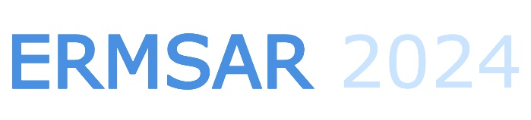 

**ERMSAR 2024 Proceedings Copyright Form**

**The Proceedings of ERMSAR 2024 Conference, including the text of all the full papers presented at the Conference, will be published in an electronic edition only under the Horizon Europe Open Access requirements for publications.**

**Manuscript Title:** ________________________________________________________________________

**Corresponding Author’s Name:** ____________________________________________________________

*(This form must be completed and signed by the corresponding author on behalf of all authors)*

The corresponding author certifies and warrants that:

* he/she is the author and proprietor of the article:
* he/she has not granted or assigned any rights of the article to any other person or body, and
* This paper contains works that have not previously published or not under consideration for publication in other journals.

**Copyright and Licensing**

**For all articles published in ERMSAR 2024 Proceedings, copyright is retained by the authors.**

**Articles are licensed under an open access Creative Commons CC BY 4.0 license, meaning that anyone may download and read the paper for free.**

In addition, the article may be reused and quoted provided that the original published version is cited. These conditions allow for maximum dissemination and exploitation of the work, while ensuring that the authors receive proper credit.

In exceptional circumstances articles may be licensed differently. If you have specific condition (such as one linked to funding) that does not allow this license, please mention this to the Conference Organizers at submission. Exceptions will be granted at the discretion of the publisher.

**Reproducing Published Material from other Publishers**

It is absolutely essential that authors obtain permission to reproduce any published material (figures, schemes, tables or any extract of a text) which does not fall into the public domain, or for which they do not hold the copyright. Permission should be requested by the authors from the copyright holder (usually the Publisher, please refer to the imprint of the individual publications to identify the copyright holder).

Permission is required for:

1. Your own works published by other Publishers and for which you did not retain copyright.
2. Substantial extracts from anyone's works or a series of works.
3. Use of Tables, Graphs, Charts, Schemes and Artworks if they are unaltered or slightly modified.
4. Photographs for which you do not hold copyright.

Permission is not required for:

1. Reconstruction of your own table with data already published elsewhere. Please notice that in this case you must cite the source of the data in the form of either "Data from..." or "Adapted from...".
2. Reasonably short quotes are considered fair use and therefore do not require permission.
3. Graphs, Charts, Schemes and Artworks that are completely redrawn by the authors and significantly changed beyond recognition do not require permission.

**Obtaining Permission**

In order to avoid unnecessary delays in the publication process, you should start obtaining permissions as early as possible. If in any doubt about the copyright, apply for permission. It will be not possible to material from other publications without permission.

The copyright holder may give you instructions on the form of acknowledgement to be followed; otherwise follow the style: "Reproduced with permission from [author], [book/journal title]; published by [publisher], [year].' at the end of the caption of the Table, Figure or Scheme.

Corresponding author: _______________________ _______________ ___________________

Affiliation: ______________________________________________________________________

E-mail Address: ___________________________________________________________________

Signature Date